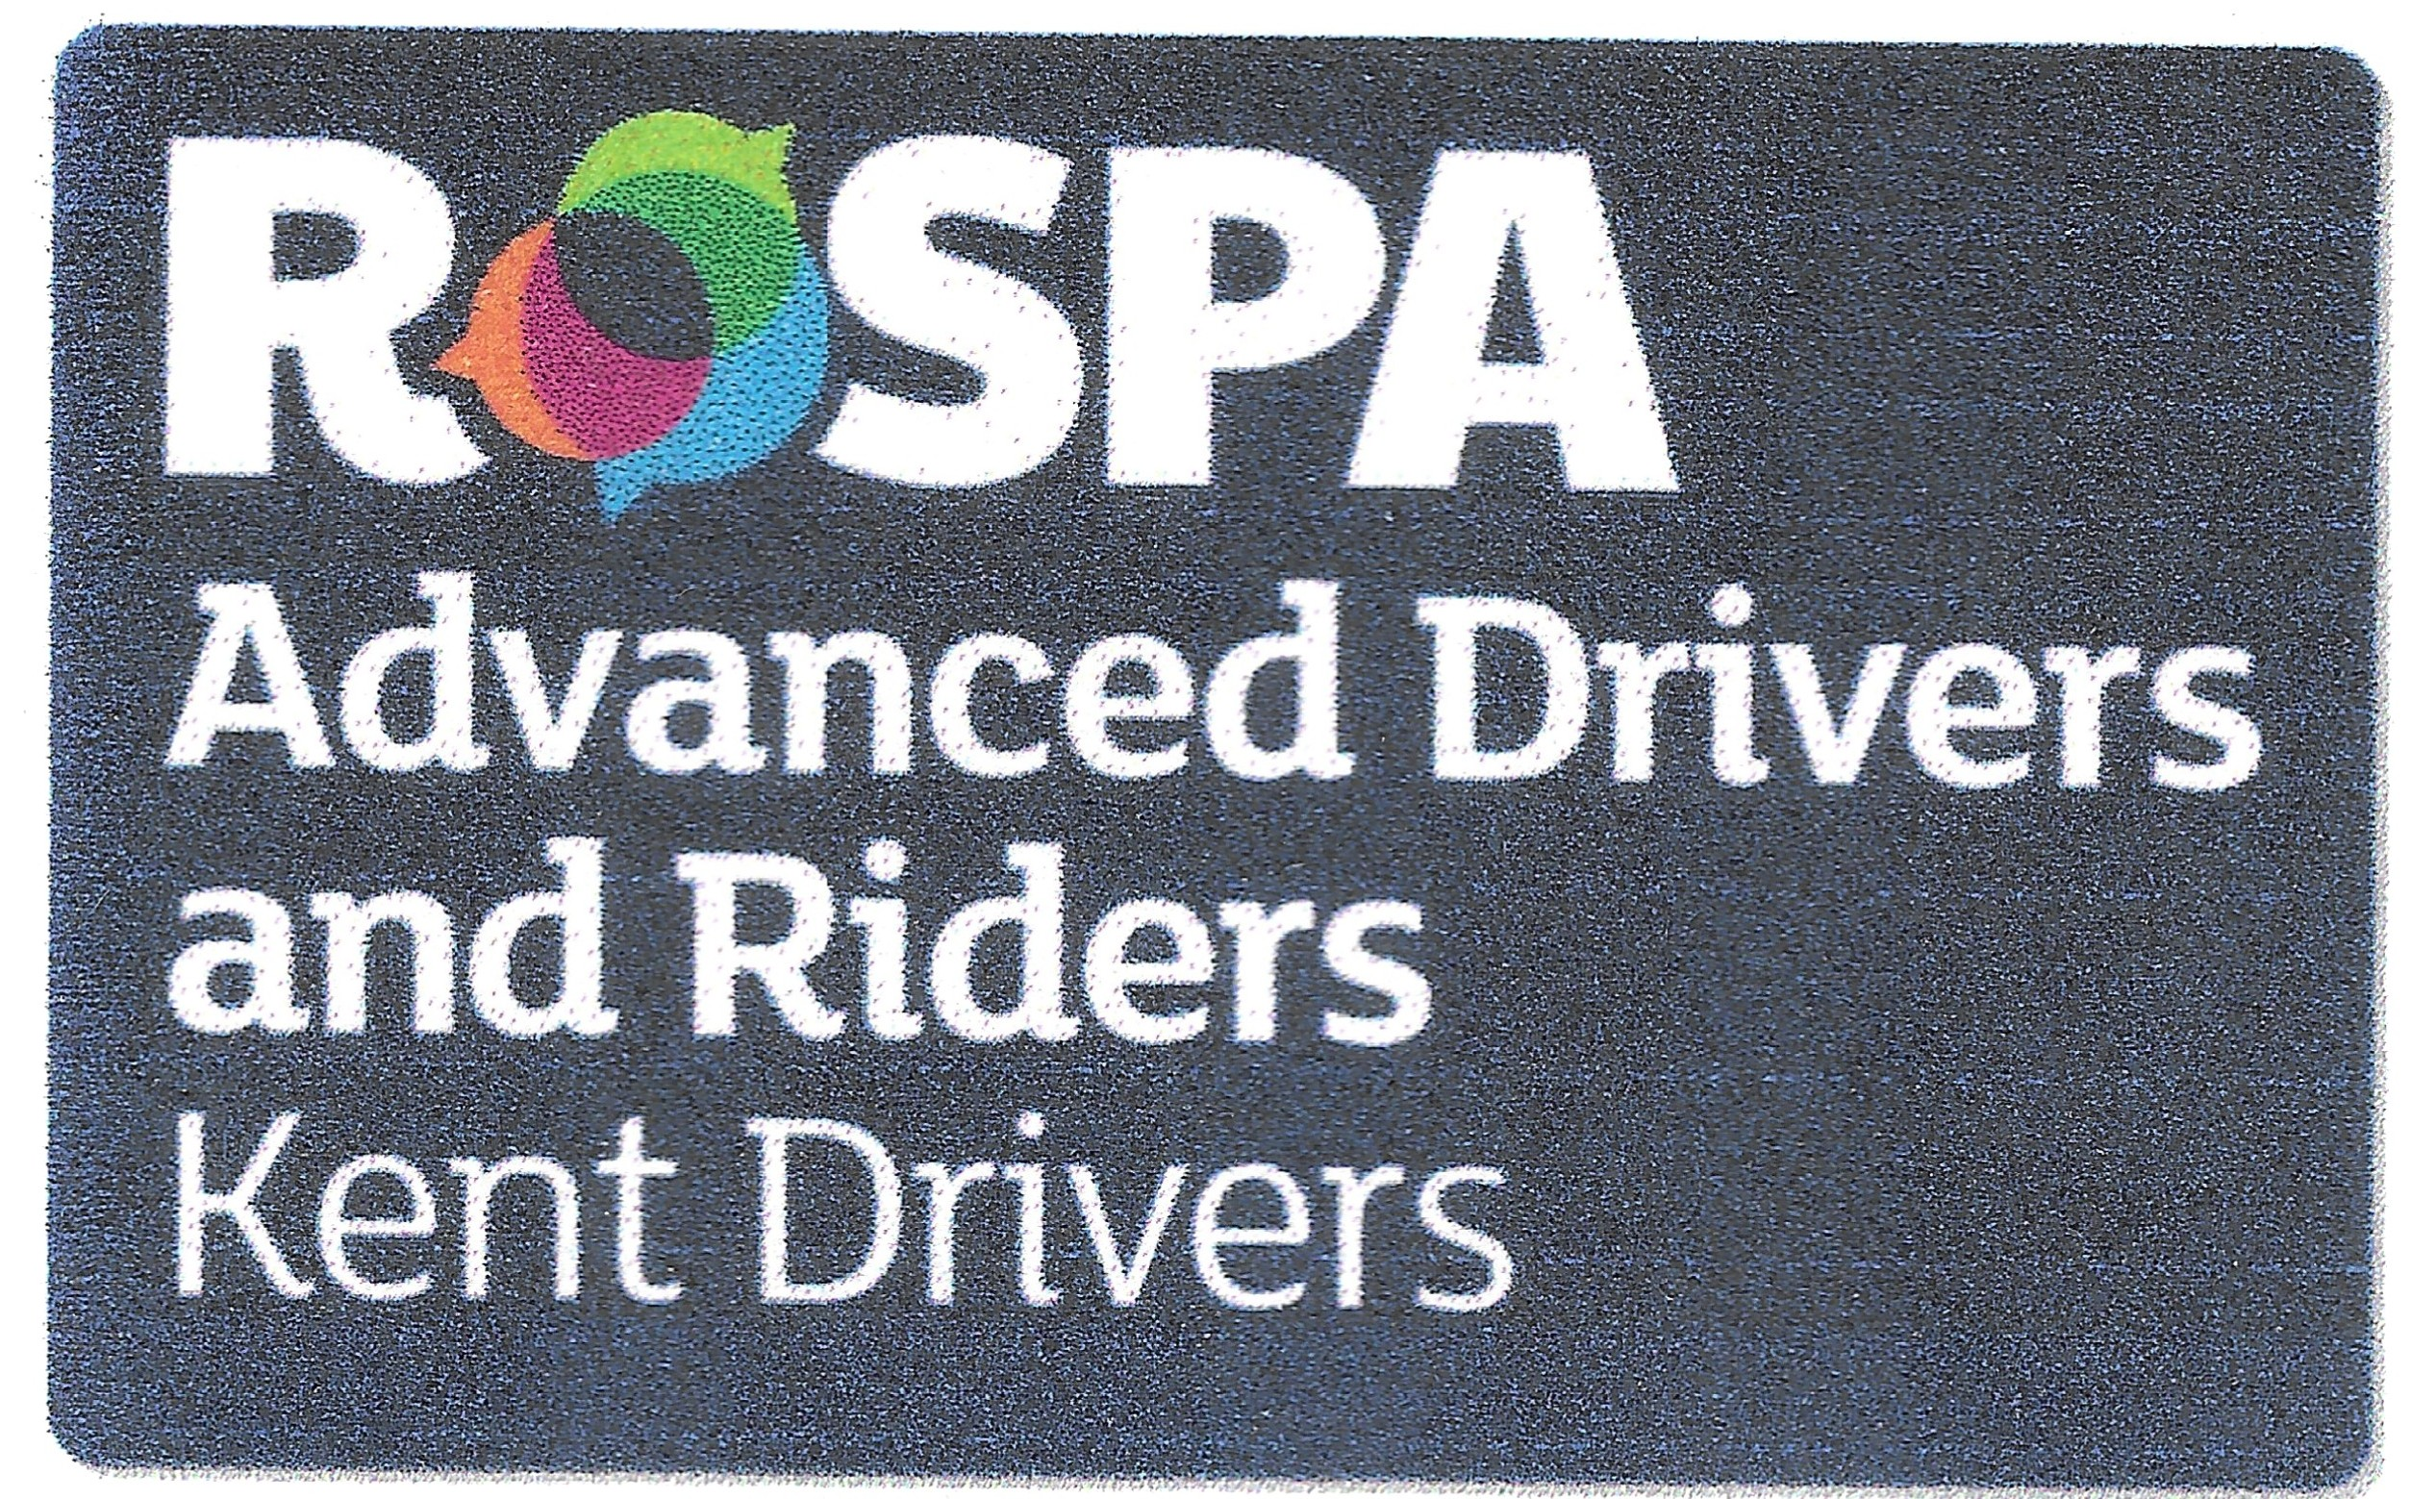
Kent RoSPA Advanced Drivers
Membership Application Form

Before applying to take the RoSPA Advanced driving test you can apply to become an associate member of the Kent Group RoSPA Advanced Drivers. When you have been accepted the group will tutor you up to test standard using your own car. This tuition is included in your membership payment. When you have passed the test at either Bronze, Silver or Gold you will be considered to be a full member of the group. The RoSPA Advanced Driving Test is always carried out by either a retired of serving traffic police officer.
Title …… First Name ………….……….…. Surname …………..….………………...…..
Address ………………………………………………………………………………………..
Town …………………. Post Code …….…… Age if under 26 ……………
Email Address ………………………………………………………………………….……..
Phone Number ……………..….………. Date Passed UK Driving Test …………………..
Car Make & Model …………………………… Occupation ………………………………...
By signing I agree that the information given here is kept electronically for the purpose of keeping me informed of the group activities and membership records. All of your details are only accessed by committee members who need access to perform their group duties. If you leave the group all of your details will be erased
I confirm that I have held a full UK driving licence for a minimum of 1 year and that my vehicle is roadworthy, taxed, insured and has a valid MoT where applicable.
Signature ………………………………………………...… Date ……………..
Payment:
The first Year of membership costs £45, the second and subsequent year’s costs £30 If you are under 26 years old the Fee is £20 until you become 27 years old.
Payment may be made on-line (preferred). Pay to “Kent RoSPA Advanced Drivers” Sort Code 23 05 80 Account Number 29335338 and quote your initial-last name-postcode as a reference.
Please email this completed form to kentrospamembership@gmail.com

